San Juan Basin Archaeological Society

a Colorado Nonprofit Corporation

Field Trip Report

Destination: Aztec Ruins Indigenous Cultural Arts Festival
Organizer: Susan Hicks Date: September 13, 2026
Number of Participants: 2

Two of us ventured down to Aztec Ruins National Monument to attend the 2026 Indigenous Cultural Arts Festival. This event featured diverse artists from various Southwest nations who demonstrated their techniques and sold their original creations. From contemporary to traditional, artists featured pottery, jewelry, basketry, and more. There were also dances throughout the day. (text from the Aztec Ruins National Monument website).

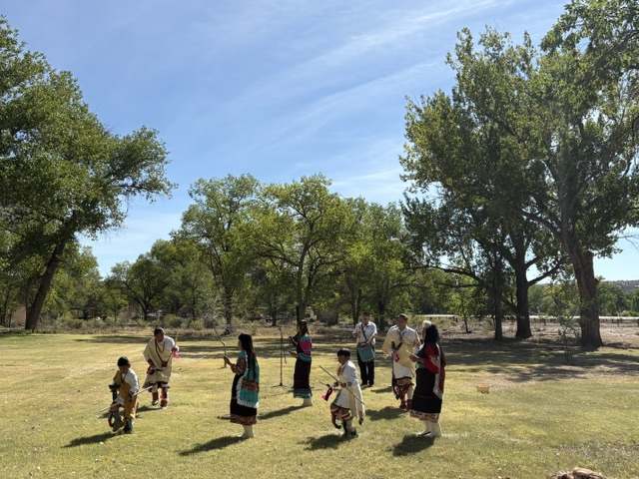
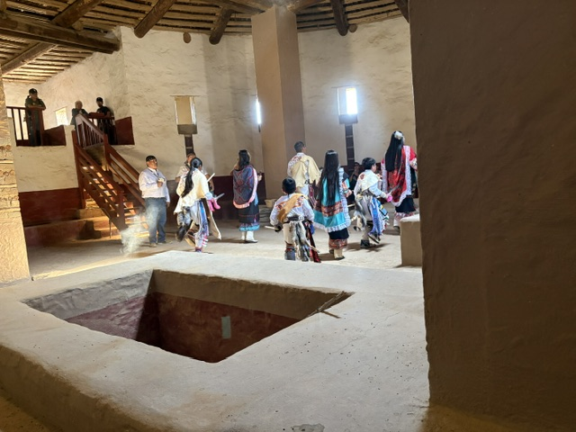
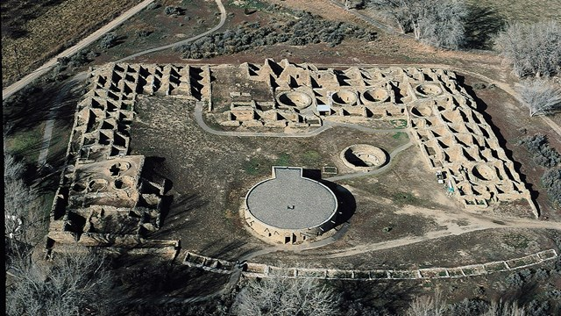
We arrived just before the first dance which was performed by the Acoma Family Dance Group, a fourth generation dance group from the Pueblo of Acoma. “Through their dancing, they honor their heritage, connect generations new and old to each other and to their cultural traditions, and foster a deeper understanding of Acoma Pueblo culture and history.” We were lucky enough to see them perform both outside under the cottonwoods and inside the reconstructed Great Kiva. We then toured the artists’ exhibits and learned about their work. They are very talented and creative!

According to its website, “Aztec Ruins has some of the best-preserved Chacoan structures of its kind”. We followed the excellent self-guided tour and learned details about the structures, preservation, sacred spaces, and culture.
Photo Source: National Park Service

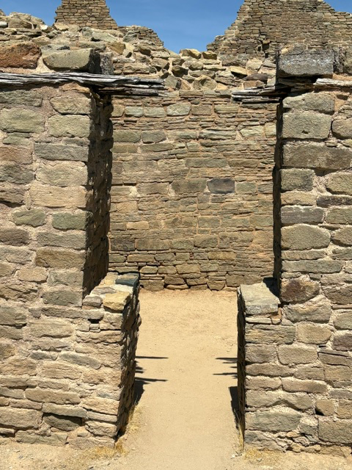
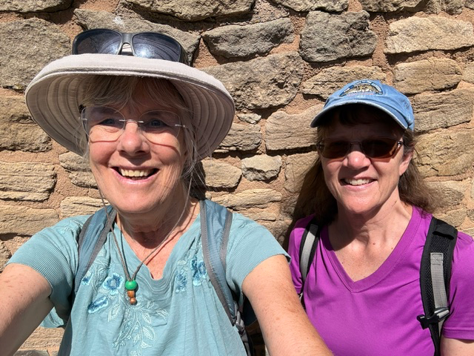
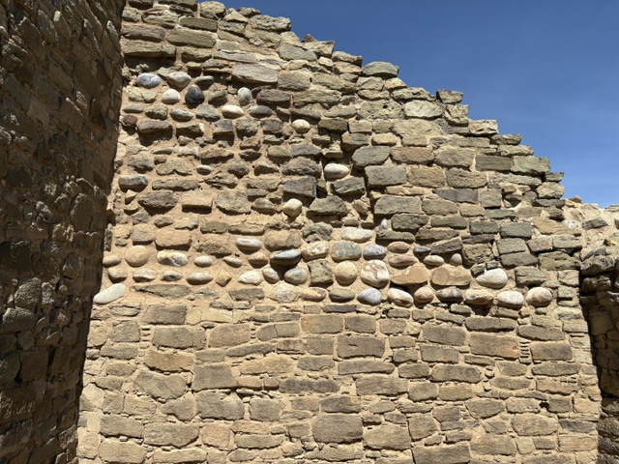

We then ate a delicious lunch at Rubia’s Fine Mexican Dining Restaurant in Aztec and then headed home.

Participants: Susan Hicks, Sandy Hoagland

