San Juan Basin Archaeological Society
a Colorado Non-Profit Corporation

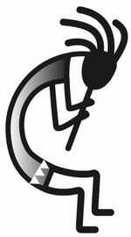

Field Trip Report

Trip Description: Pecos Conference 2026 Date: August 6-9 2026

Trip Leader(s): Rusty Chamberlain Participation Limit: __No Limit__

Participants:
Rusty Chamberlain, Lisa Coash, Tammie Barger, Joel Barger, Thom Polich,
Betsy Moore, Phil Bruckbauer, Peter Jameison, Lynn Hughes, Jim Horn, Maro Borrero

Remarks:
Each August, archaeologists and associated scientists gather under open skies somewhere in the southwestern United States or northwestern Mexico. We set up a large tent for shade, and then spend three or more days together discussing recent research, problems of the field, and the challenges of the profession. The first Pecos Conference was inspired and organized by A.V. Kidder in 1927 at Pecos Pueblo. It was during that first conference that gave us Pecos classification system.

In 2026 the 4-day conference began on Thursday evening with a reception at Millie’s in Mancos. This a chance to meet and re-meet folks attending the conference and to get your credentials. The conference took place on Friday and Saturday on Doc Lowell Flat in the mountains above Mancos. There the participants gave their talks in the presentations tent. Over the 2 days we heard almost 30 discussions from Chaco rock art, use Chacoan Roads in rituals, Ancient Puebloans as astronomers and how archaeological field training has changed at Fort Lewis College.

On the same days in another tent participants shared posters describing their research. In another big tent,16 or so vendors displayed books, crafts, and information. And along the back and side wall were items displayed for the silent auction in support of scholarships. Joel and Rusty each big hunks of obsidian flint knapping demonstrations.

On Friday evening was open mic night. I was not able to stay for that heard reports a fun time. After lunch on Saturday the vendors packed up their wares so that the tent could be rearranged for the dinner catered by Via Tacoria. At 5:15 we had happy hour with beer from Wild Edge Brewing Collective of Cortez and then dinner. About 7:30, the indigenous band Innastate brought their high-energy blend of roots-rock reggae, and soulful grooves in the converted presentations tent. Check them out on YouTube.

Sunday is always Field Trip Day. Joel and Tammie Barger took a tour of Jackson’s Castle. I chose a tour of the PI/PII great house community in Morefield Canyon of Mesa Verde National Park since it something I would never see if note for the field trip. I was joined Thom Polich, Peter Jamieson, Betsy Moore, Phil Bruckbauer and Mario Borrero. Lynn Hughs and Jim Horn signed for the tour to Oak Tree House and Fire Temple in Mesa Verde.

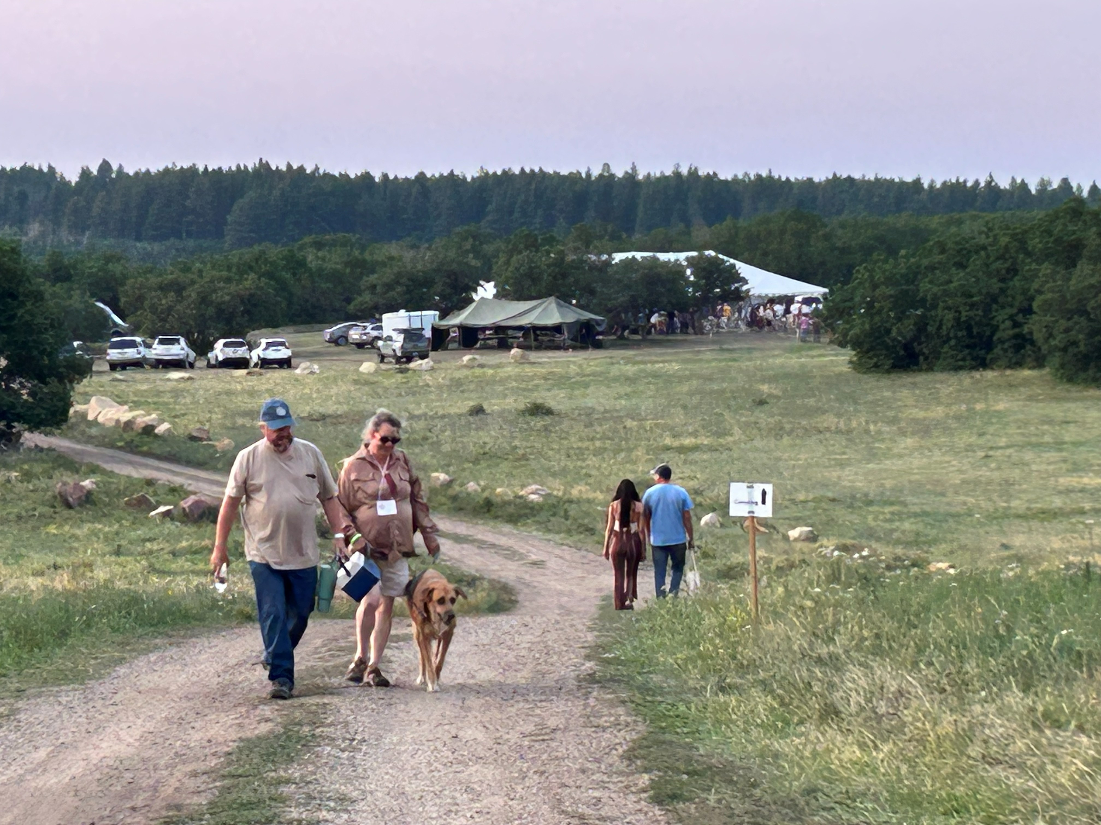Doc Lowell Flat site of Pecos 2026

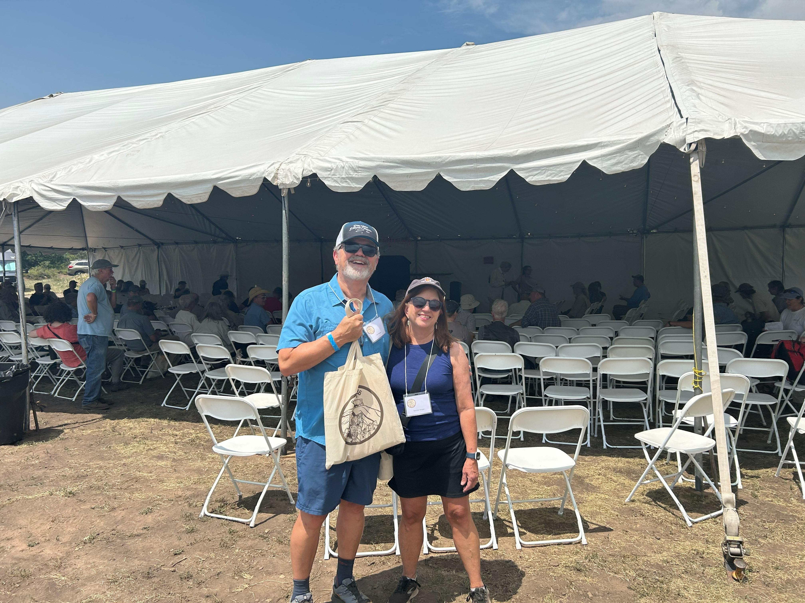Joel and Tammie in front of the presentations tentPosters tent Pecos 2026

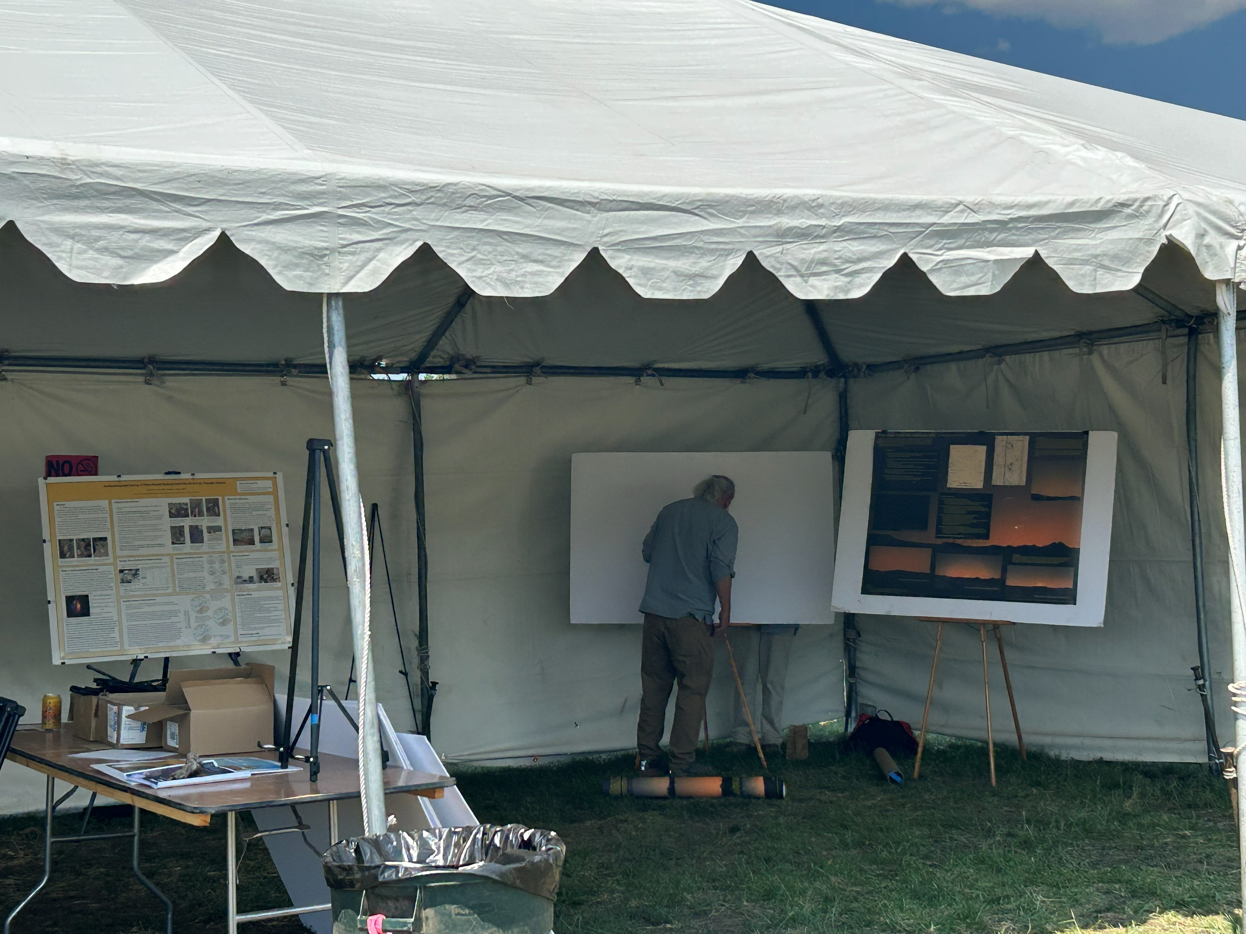Posters tent Pecos 2026

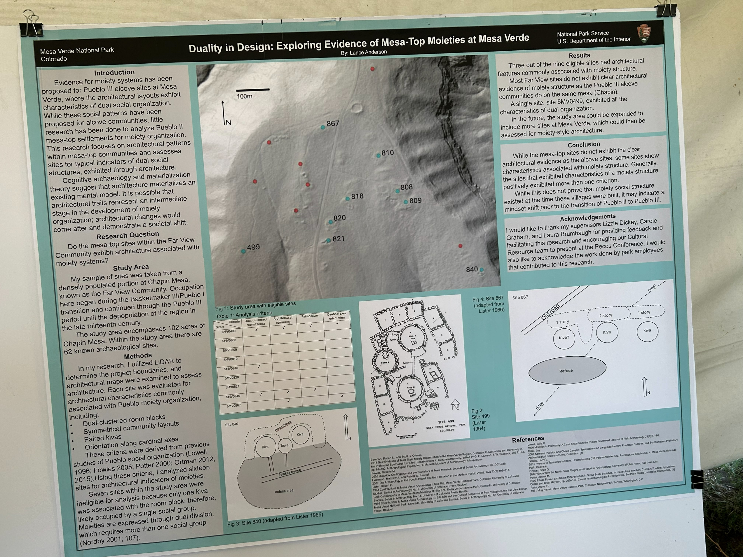Poster on Mesa Verde dual-moieties Pecos 2026

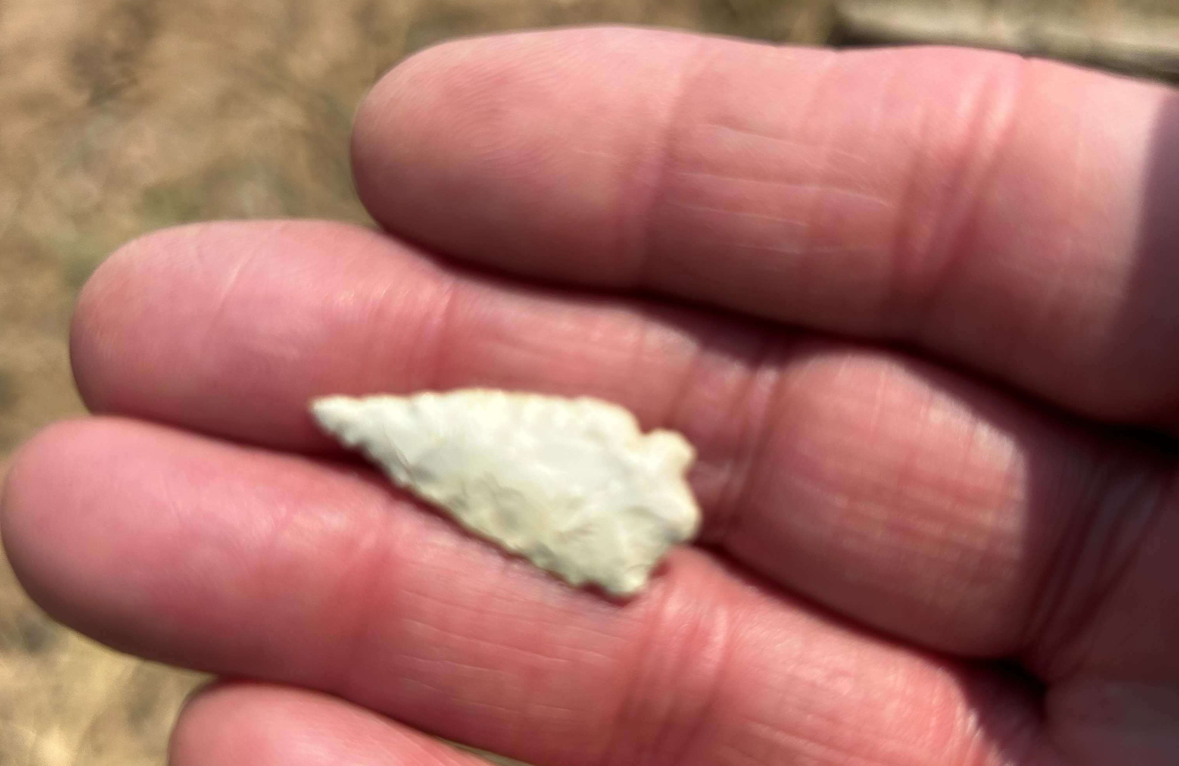Morefield Canyon PI arrow point 2026

Prepared by Rusty Chamberlain

